# Task 3

Create an user registration form with following details.  
-Username (minimum 6 characters)  
-Password (minimum 8 characters)  
-Confirm Password  
-Email (valid email)  
-Mobile phone number (10 digit number)  
-Address with street ,city & postal code  
-Profile picture (required)  
-Submit button  
**After submit, user should be able to view his profile with above details (**use html/css/jquery or js)

This is a complete registration form. There are two pages. Register page and profile page. So first I create a register form including above fields. I use simple html tags for creating this page. There are 7 details and submit button. But I use 10 text fields for this. I user 3 fields for get address because I want to get street name, city name and postal code. Also I include hidden text field for profile picture. Because I use base64 method for pass image data to profile page. that hidden text filed assign the image’s base64 value. This is brief detail of the task.

1st I create form with above details. All fields data are required (use **required** attribute). I validate all the fields.

* User name (minimum 6 characters) – minlength=”6”
* Password – there also use **minlength** attribute. In password validation we have to check the password and the confirm password  is matched. So I user script for that. [**onkeyup=’check();’]** it check the two values of that two fields while typing password.
* Email - it check the input is **email** type data.
* Mobile – mobile number have a 10 digits. So length set to 10 digits. (use **maxlength** attribute)
* Address – it get using three input text fields.
* 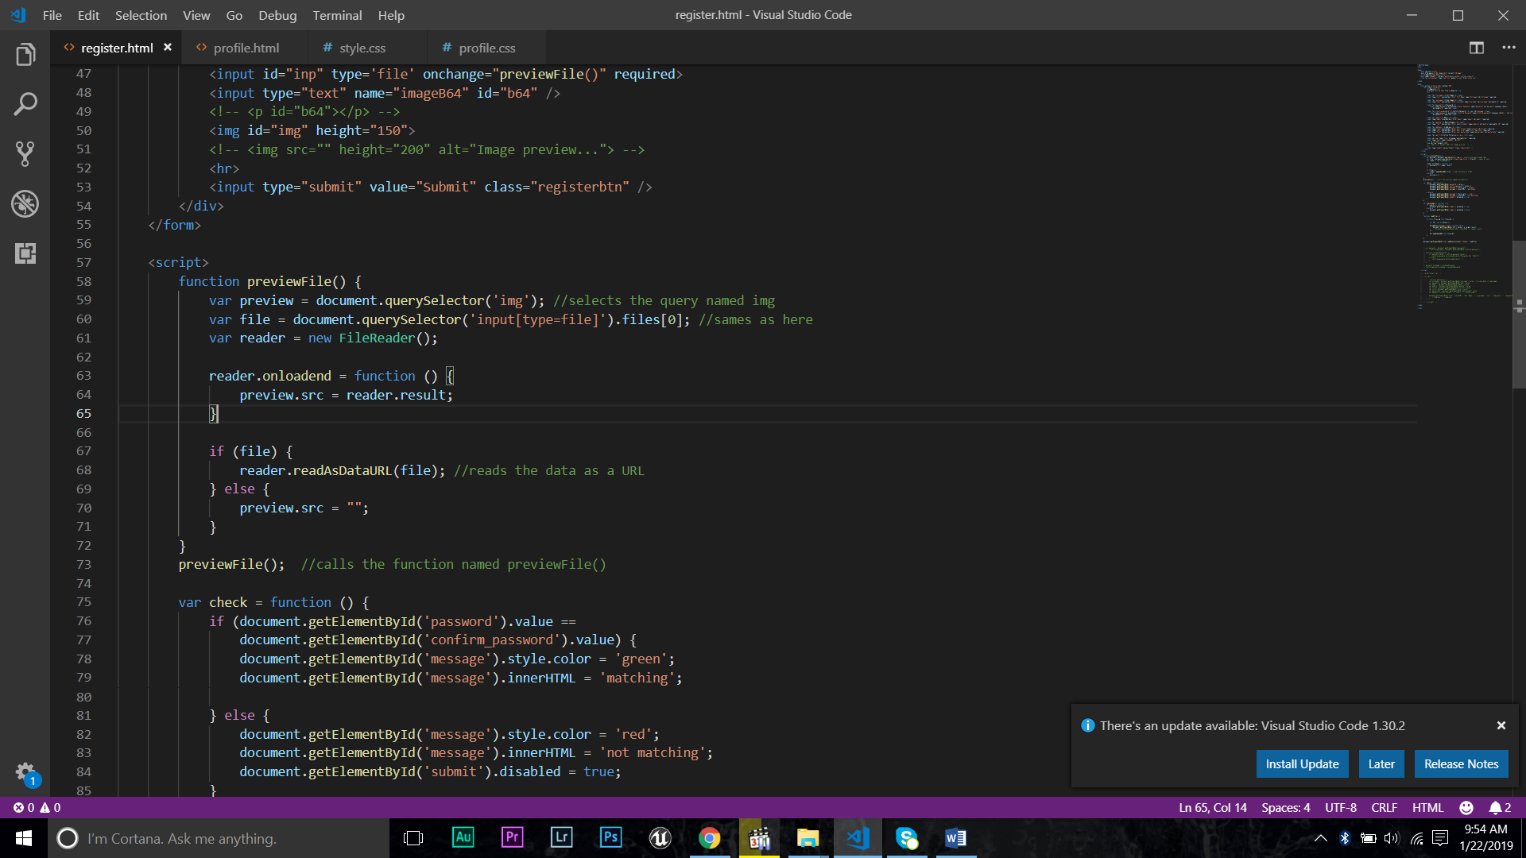Profile Picture – user can add picture. (use **file** type) after upload image I want to preview that. so I use script for that. (**previewFile()**)
* Also I add text field for pass the base64 value of the image. I use script for that. script return base64 value then it assign to that hidden text field by using script id. { **input type=”hidden” name= “image64” id=”b64” />** } I use base64 conversion because it is easy to pass the image data to another html.
* So last thing is submit button. Clicking submit button I have to pass values to another html. So I use **GET** method for that. also use **action** attribute to link other page. after submitting values sent to profile page url.
* Then I create profile page. it also form. I have display registration details in this page. details are in url so I have to get those details. I write a script for get those details. (**getQueryString()**) this function return the all input data.

***function getQueryString() {***

***var result = {}, queryString = location.search.slice(1),***

***re = /([^&=]+)=([^&]*)/g, m;***

***while (m = re.exec(queryString)) {***

***result[decodeURIComponent(m[1])] = decodeURIComponent(m[2]);***

***}***

***return result;***

***}***

So then we have all the data. We have to get details separately. we can use script for that. calling to name attribute we can get separate value and assign to new id to pass data in view.

Eg. Get username value

***let username = getQueryString()["username"];***

***document.getElementById("username").innerHTML = "User Name : " + username;***

* ***getQueryString()*** is a function. Username is a name attribute of the user input. After getting value it assign new variable username. Finally pass the value to display. (***innerHTML = "User Name : " + username;)***
* To view this we have call username id.( ***<p id="username"></p>*** )

We get address as a three user input. So I create address using **concat** method. [ **let address = street.concat(", " + city + ", " + postalcode);** ]

Image value also get above method. But we have pass the value to source (src). I use setAttribute function to it. [**document.getElementById("b64").setAttribute('src', image);** ] then I assign that value using img id.